**git commands**

//this command brings the github file in that link to your folder code in D drive

D:\code>git clone <https://github.com/saiprashanth14/gitprac1.git>

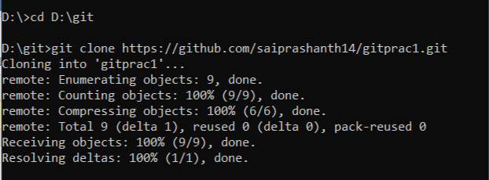

and you can externally add files into the folder but this will not be updated in the main github repo. and you can use dir u see what files are there

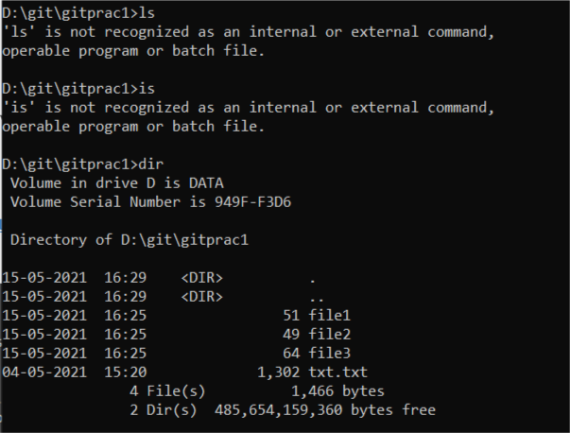

//this command allows to see which files are there and not there in your main github repo

**git status**

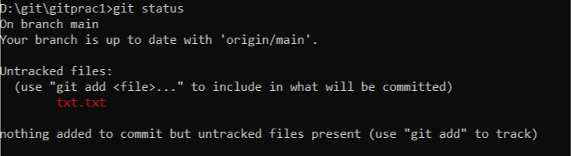

**//**to add files into the github repo

**git add <filename>**

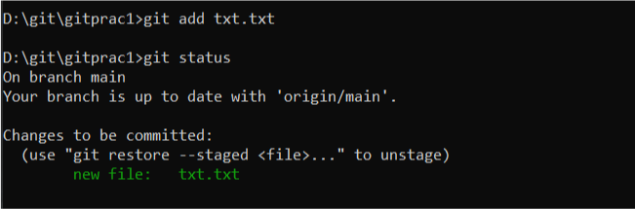

//But that’s not enough to made changes in main github repo

//Do this

**git commit -m “added this file”**

// this command commits with the messege “added this file”

//and finally u need to push

**git push**

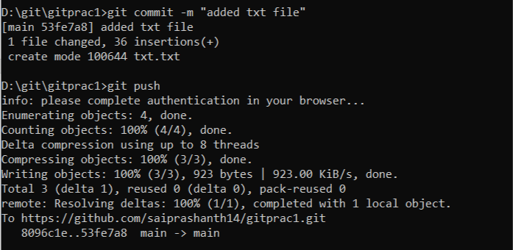

//To save changes made in a file

**git add .**

**git commit -m “messege”**

**git push**

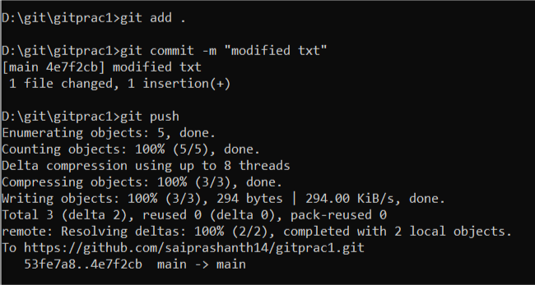

//suppose u modified a file in your github main repo in order to reflect that changes in your file in your type **git pull** command

**git pull**

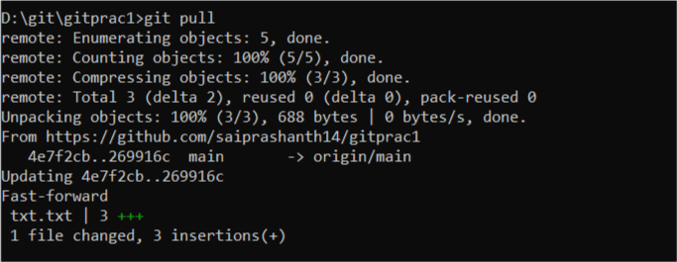

**git branch** //to check which branch u r

**git branch littlefeature** // to create a branch named littlefeature

**git checkout littlefeature** // to switch to that new branch follow the commands

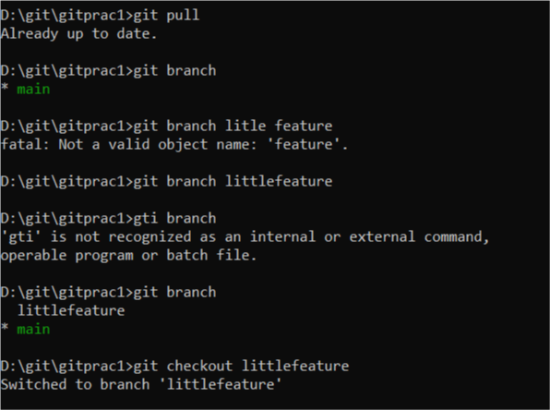

But still we need another command to completely switch to the new branch

**git push --set-upstream origin littlefeature**

